Matthew Hill – 17030500
Sam Sloman – 17027237
Deyvid Gueorguiev – 17017455

UWE Accommodation System – Testing Documentation

OOSD2 – Testing

Testing
Our testing strategy was composed around two elements; JUnit testing and more conventional black box testing strategy for this project.
We choose to carry out JUnit testing as this allows us to verify strict compliance with the requirements in a programmatic way, however as some of our Classes are obviously displayed on-screen and also our JUnit classes exist externally from our instantiations of the JavaFX classes which adds in additional complexity it as deemed necessary to test the displayed classes by interacting with our programme rather than through JUnit.
JUnit
Fundamentally our JUnit testing is due to there being a room inside the black box of our programme for instance attributes to be altered without warning us. As testing our getters and setters is an extremely simple process, I’ve condensed the test methods down in several places into doing both getting and setting the attribute; running additional tests to inside a method to ensure robustness. As long as our tests pass, we can then be assured that our program operates on a solid foundation. The success criteria in the JUnit tests vary from test to test so print screens of each can be found below with evidence of the success and failure criteria. The actual JUnit scripts can be found in the root level of our project inside the ​tests ​directory
Black Box
For testing the front end (graphical user Interface) we used black box testing to ensure usability. As software developers we understand the code and its functionality, however we needed to take in to account a user’s point of view where they have no knowledge of the back end of the system.

Some of the advantages to this are – the tests as mentioned can be done from the user’s point of view, this will help in exposing discrepancies in the specifications.

The tester doesn’t need to know or have any prior programming knowledge or understanding of the software implemented.
Tests can be conducted by a body independent from the developers, allowing for an objective perspective and the avoidance of developer-bias.
Test cases can be designed as soon as the specifications are complete.
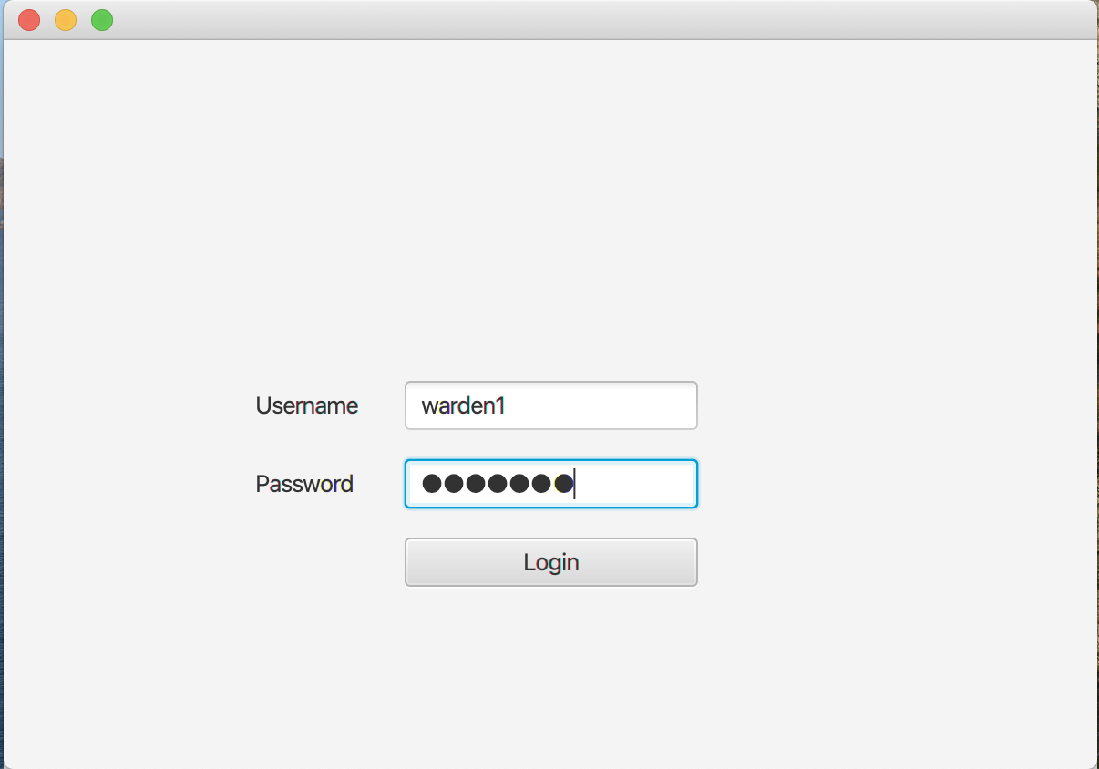
The screen shot above shows the Precondition of the warden login after the program has been loaded.

Expected Result
Once the log in has been accepted, the program will log in and give the warden access to view the hall he has be allocated to.
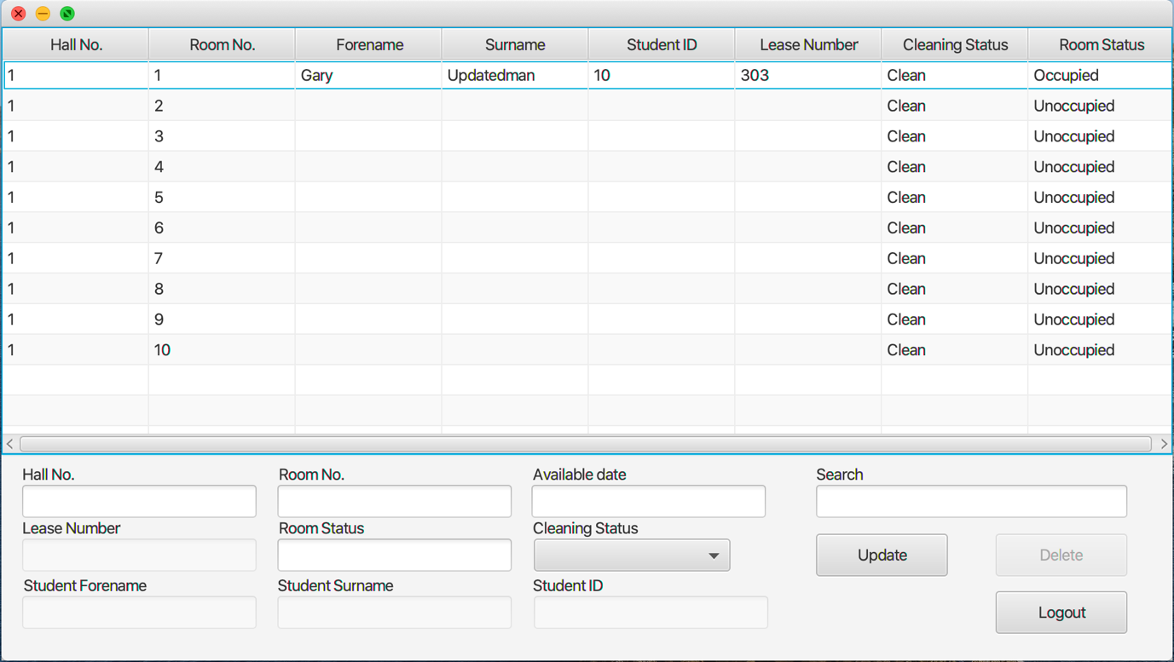
The screen shot above shows the Post - condition of the warden login after the program has been loaded, giving the warden access.

We continued the same process to test for creating a new lease, updating a lease and deleting a cleaning status. see the screen shots below for pre and post testing.

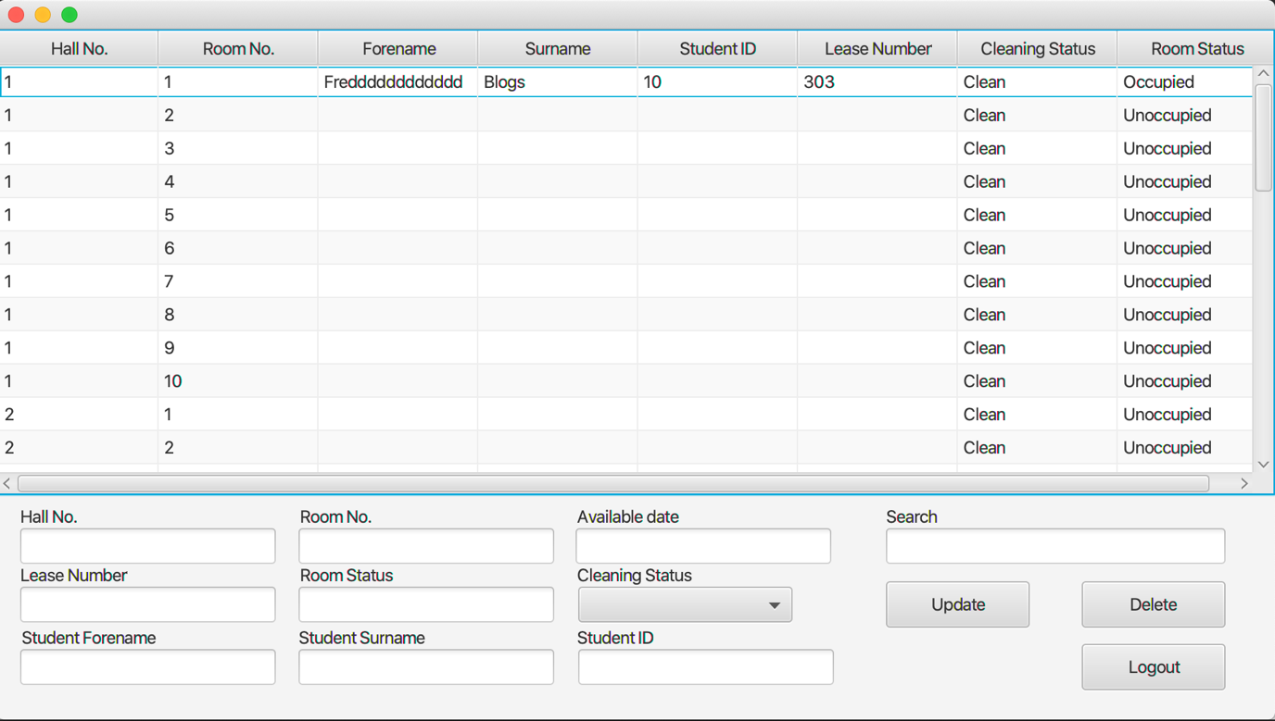
Pre Condition – Lease Update.

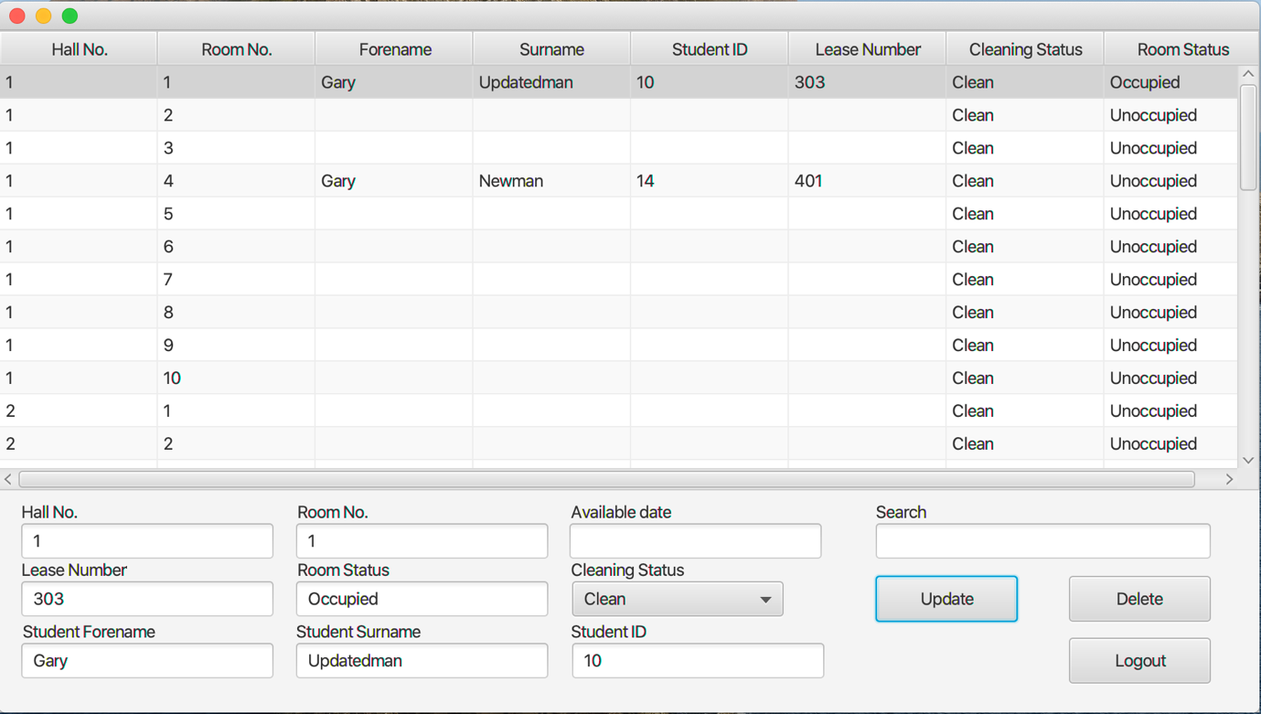
Post condition – Lease update.

Pre-Condition – Creating a new Lease.

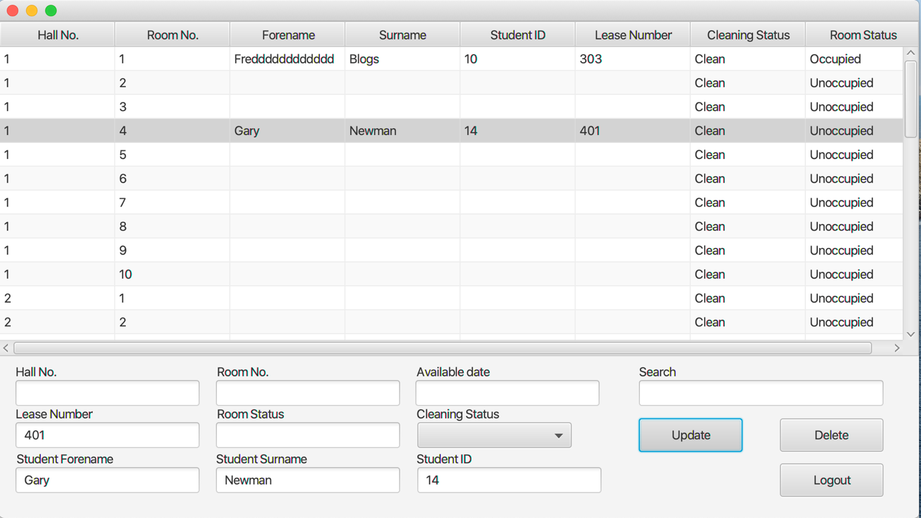
Post Condition – Creating a new lease.

Pre-Condition – Deleting a cleaning status.

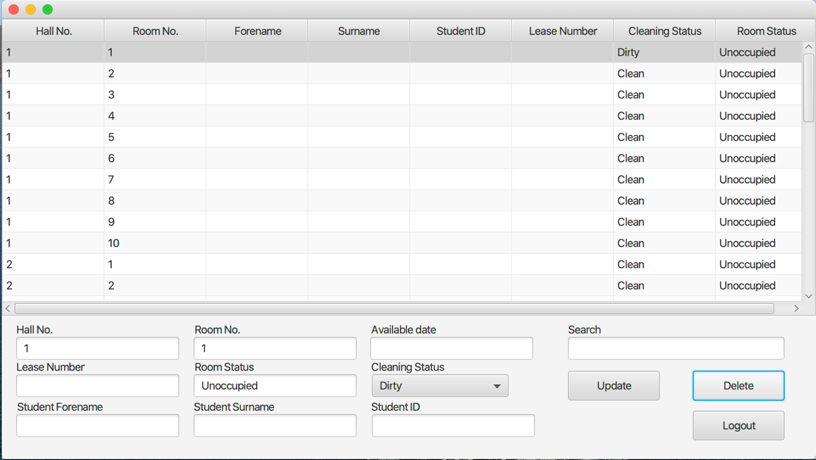
Post Condition – Deleting a cleaning status.

Hall Test

Test Case/ Use case Inputs | Purpose | Expected Result | Comments
Test Add Room() | Testing to see if rooms where successfully added to Halls | Post condition is met, test was successful. | Successful test, no changes to be made.  (See below)
Test Get Rooms() | Testing to retrieve the added rooms. | Post condition is met, test was successful. | Successful test, no changes to be made.  (See below)
Test Get Name() | Testing to get the added name. | Post condition is met, test was successful. | Successful test, no changes to be made.  (See below)
Test Get Address() | Testing to get the added address. | Post condition is met, test was successful. | Successful test, no changes to be made.  (See below)
Test Get Tele Number() | Testing to get the added Tele number. | Post condition is met, test was successful. | Successful test, no changes to be made.  (See below)
Test Get Hall Number() | Testing to get the Hall number. | Post condition is met, test was successful. | Successful test, no changes to be made.  (See below)

Copy of Hall Tests Passed

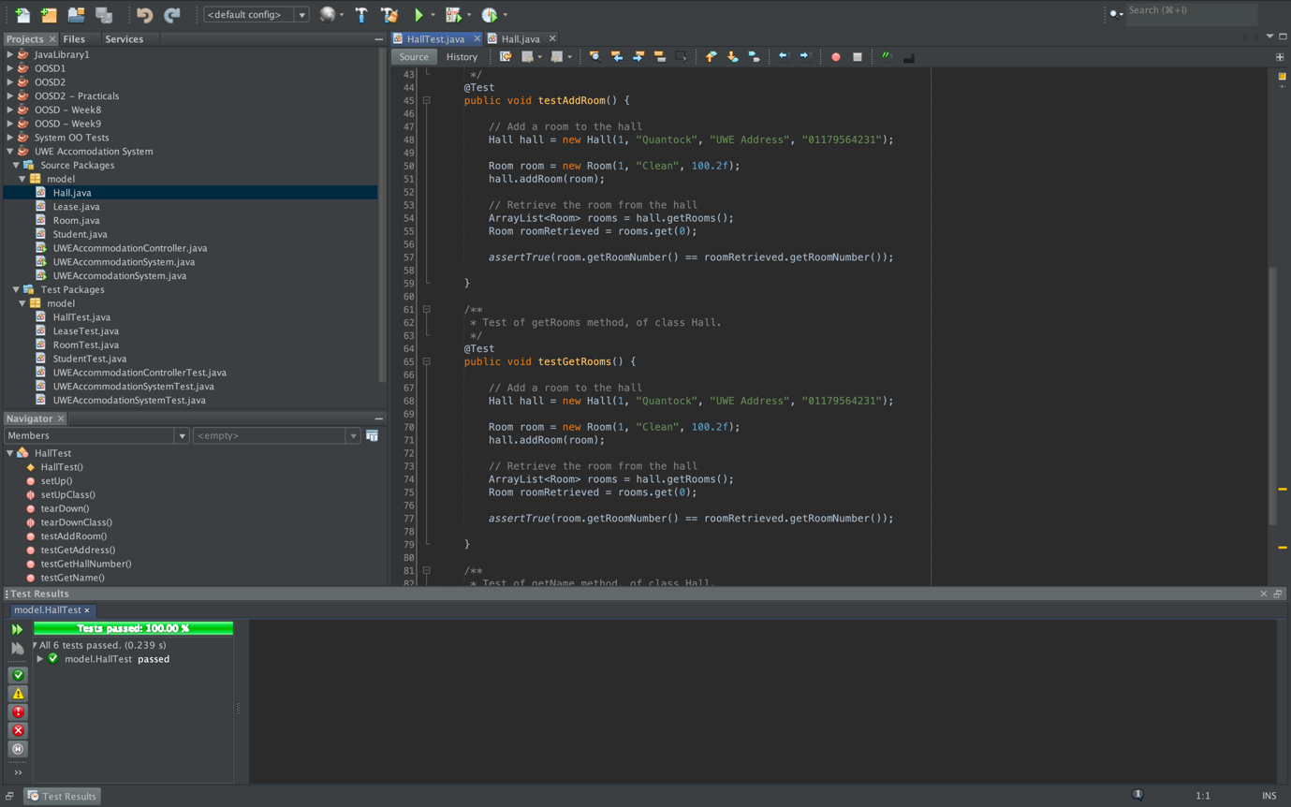

Lease Test

Test Case/ Use case Inputs | Purpose | Expected Result | Comments
Test Set Lease Number() | Testing to set a number to a Lease | Post condition is met, test was successful. | Successful test, no changes to be made.  (See below)
Test Set Lease Duration() | Testing to set a Duration to a Lease | Post condition is met, test was successful. | Successful test, no changes to be made.  (See below)
Test Get Lease Duration() | Testing to get the set Lease duration. | Post condition is met, test was successful. | Successful test, no changes to be made.  (See below)
Test Set Student() | Testing to add/set a student. | Post condition is met, test was successful. | Successful test, no changes to be made.  (See below)
Test Get Student() | Testing to get the added student. | Post condition is met, test was successful. | Successful test, no changes to be made.  (See below)
Test Set Start Date() | Testing to add a start date. | Post condition is met, test was successful. | Successful test, no changes to be made.  (See below)
Test Set End Date() | Testing to add a end date. | Post condition is met, test was successful. | Successful test, no changes to be made.  (See below)
Test Get End Date() | Testing to retrieve the set end date. | Post condition is met, test was successful. | Successful test, no changes to be made.  (See below)
Test Get Start Date() | Testing to retrieve the set start date. | Post condition is met, test was successful. | Successful test, no changes to be made.  (See below)

Copy of Lease Tests Passed

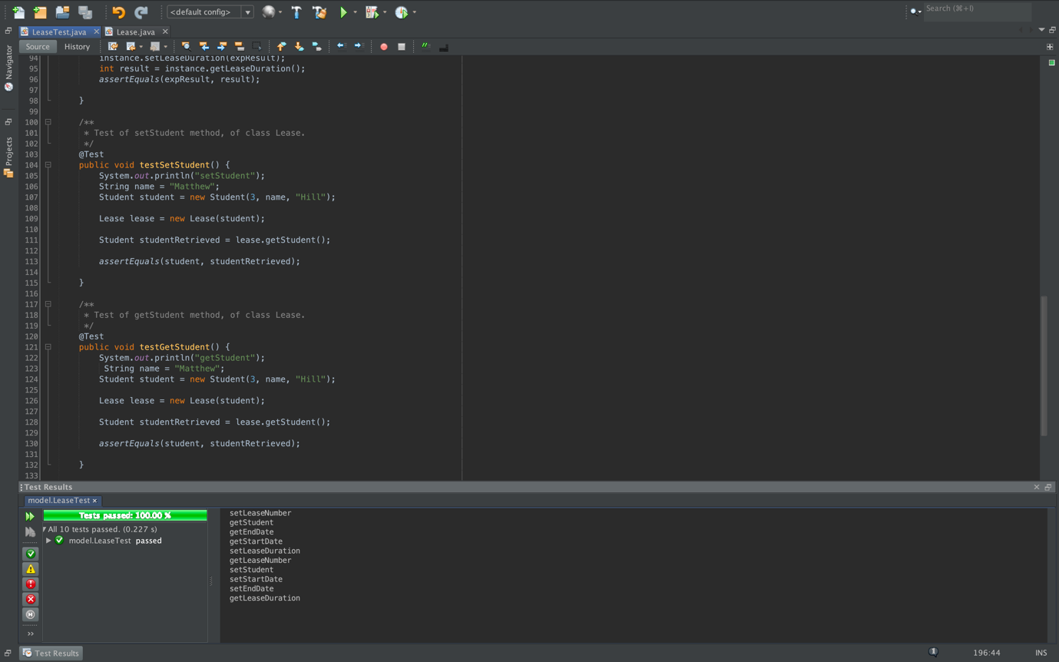

Room Test

Test Case/ Use case Inputs | Purpose | Expected Result | Comments
Test Get Room Number() | Testing to get the room number. | Post condition is met, test was successful. | Successful test, no changes to be made.  (See below)
Test Set Cleaning Status() | Testing the set cleaning status. | Post condition is met, test was successful. | Successful test, no changes to be made.  (See below)
Test Is Occupied() | Testing to see if the room is Occupied. | Post condition is met, test was successful. | Successful test, no changes to be made.  (See below)
Test Set Monthly Rate() | Testing to set/add a monthly rate. | Post condition is met, test was successful. | Successful test, no changes to be made.  (See below)
Test Get Monthly Rate() | Testing to retrieve the monthly rate added. | Post condition is met, test was successful. | Successful test, no changes to be made.  (See below)
Test Get Room Status() | Testing to get/see the room status. | Post condition is met, test was successful. | Successful test, no changes to be made.  (See below)
Test Set Lease() | Testing to set a lease. | Post condition is met, test was successful. | Successful test, no changes to be made.  (See below)
Test Get Lease() | Testing to retrieve the lease | Post condition is met, test was successful. | Successful test, no changes to be made.  (See below)

Copy of Room Tests Passed

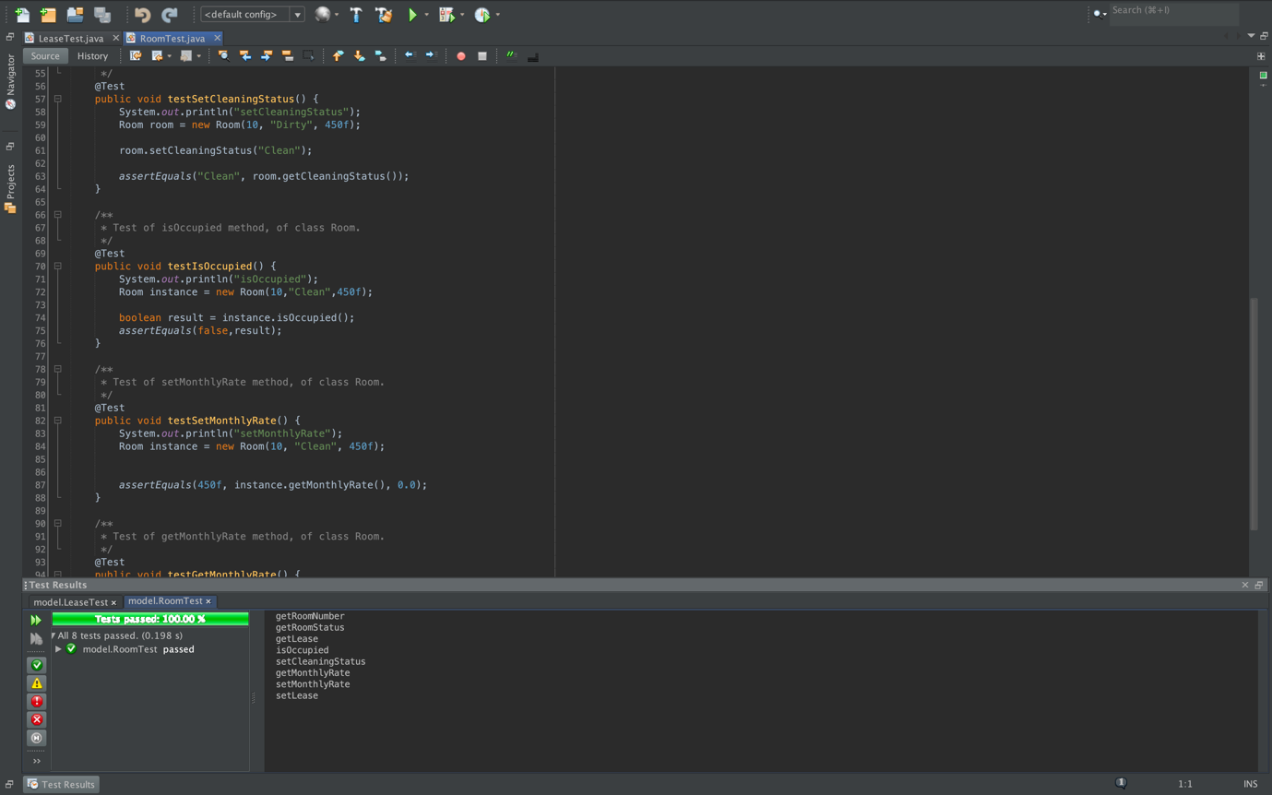

Student Test

Test Case/ Use case Inputs | Purpose | Expected Result | Comments
Test Get Student ID() | Testing to get the student ID from the student class | Post condition is met, test was successful. | Successful test, no changes to be made.  (See below)
Test Get Name() | Testing to get the student name from the student class | Post condition is met, test was successful. | Successful test, no changes to be made.  (See below)

Copy of Student Tests Passed

